Lesson Plan Title

Subject: Chemistry/Magnetism  Related Subjects: Chemical Reaction, Magnetic properties | Grade Level(s): 4  Length of Lesson: 71 minutes | Type: Inquiry / Design / Project  Keywords: Magnet, Polymerization, Attraction, Repulsion

Lesson Overview

This experiment synthesizes basic principles of chemistry and magnetism into a single activity where students create a magnetic slime. The polymerization reaction of liquid starch and glue changes the physical properties of the substance to make slime, and the iron oxide powder will make the slime attractive to magnets.

Lesson Focus
What is the central question or phenomenon being investigated? What problem are they trying to solve?

Lesson Objective(s) | - Students will understand the basic principles of polymerization reactions.  - Students will learn about magnetism.

Lesson Timing

Time [min] | Description
5 | Introduce the Lesson  - End Goal  - Primer Questions  - Key Vocab Words
1 | Role Models in STEM
Engineering Method
5 | Real World Example
5 | Hypothesis & Prediction
5 | Brainstorm & Design
20 | Build & Create
10 | Test & Record
5 | Assess & Evaluate
5 | How to improve?
10 | Lesson Cleanup

Materials | - Liquid Starch (1/4 cup)  - Elmer’s Glue (1/4 cup)  - Iron Oxide Powder (2 tbsp)  - Disposable bowls (1)  - Spoon (1)  - Magnet (1)  All amounts given are for 1 student
Instructor Prep | - Step 1
Related Resources | - List related lessons/ppts etc available from USC or outside, trusted orgs

Lesson Plan

Introduction
- What is a polymer?
  - A long chain of molecules
  - A long molecule made of many repeating small ones.
- Can you describe what a magnetic compound is?
  - It is a material made of multiple things that has magnetic properties
  - It is a homogenous mixed substance that is attracted to magnets
- What makes magnets behave the way they do?
  - Magnetic properties are produced by atomic alignment.
  - Magnets have unique atomic structures where atoms all “point” the same way, creating poles and magnetic forces.

Procedure
- Introduce lesson to students—let students know they will be making slime that can magnetize to metals.
- Let students know they magnets are attracted to iron and they will be using iron to make their slime today. Also let students know that adding iron to slime will be the way they’ll be able to make the slime magnetize to metals.
- Place students into groups of five and give students all the materials they will need to complete the experiment.
- Have the groups pour 1/4 cup of liquid starch into a bowl. Add 2 Tablespoons of iron powder and stir until well mixed.
- Have the groups add 1/4 cup white school glue and mix. It will look like a huge mess that isn’t going to turn into anything, but keep stirring!
- Have a teacher take the slime out of the bowl and mix with your hands. Squish and squish until it’s well mixed. There will be some liquid left in the bowl that isn’t part of the slime, and that’s fine. Your hands will get very black, and you should wash it off right away.
- Pat the slime dry with a paper towel to get rid of any excess liquid. The finished slime won’t make your hands black, but the extra liquid will. Once the slime is “dry,” it’s ready to play with.
- Give each table magnets and divide the slime equally between all students. Allow the students to play with the magnets and slime.

Wrap-up
The purpose of the survey is to let us know your opinions about today’s project. Remember there are no right or wrong answers.

 |  | Strongly Disagree | Disagree | Undecided | Agree | Strongly Agree
1 | The project increased my interest in science
2 | After this project, I am more confident in doing science

3. What does a chemical engineer do? (Project specific STEM professional, i.e. mechanical engineer, physicist, and biologist)

4. True/False A material’s magnetic properties have to do with the alignment of its atoms.

5. Would the slime have been magnetic if we had added powdered chalk to it instead of iron powder?

Lesson Background for Teachers

Real World Example
- Pharmaceutical companies use a knowledge of chemistry to create new drugs to treat disease
- Engineers use principles in magnetism to design magnetic rails for high speed trains

Hypothesis & Prediction
- What will the properties of the slime be, and can I predict them by simply knowing its ingredients? What does Iron Oxide do to the slime?

Brainstorm & Design
- What is the best ration to mix the ingredients for slime?
- How can I explain any byproducts left over from the reaction?
- How much Iron Oxide should I add?

Build & Create
- Students will be creating a magnetic slime

Test & Record
- Students will observe the physical properties of the glue/liquid starch solution before and after it was mixed and note the differences.
- Students will use magnets to observe how the slime reacts to magnetic fields close to it.

Assess, & Evaluate
- Students will know their experiment was successful if they can manipulate the slime with magnets (without touching it).

How to Improve?
- Do you think adjusting the chemical ratios would improve or worsen the design?

Lesson Variations and Options
Include descriptions of alternative methods or ways to present things.

Explanation
Describe the background concepts and explanations behind the lesson. This can be more in depth than a teacher/instructor would actually share with students.

Key Concepts and Vocabulary
- Magnet
  - An object that has its atoms so ordered that it aligns itself in an external magnetic field
- Poles
  - The opposite ends of a magnet that produce repulsive or attractive forces.
- Repulsive force
  - A kind of force that pushes to objects away from each other.
- Chemical reaction
  - A process involving rearrangement of a substances molecular structure
- Polymerization
  - The process by which molecules are linked to form a polymer

Safety Notes
- Safety instruction

Role Model in STEM

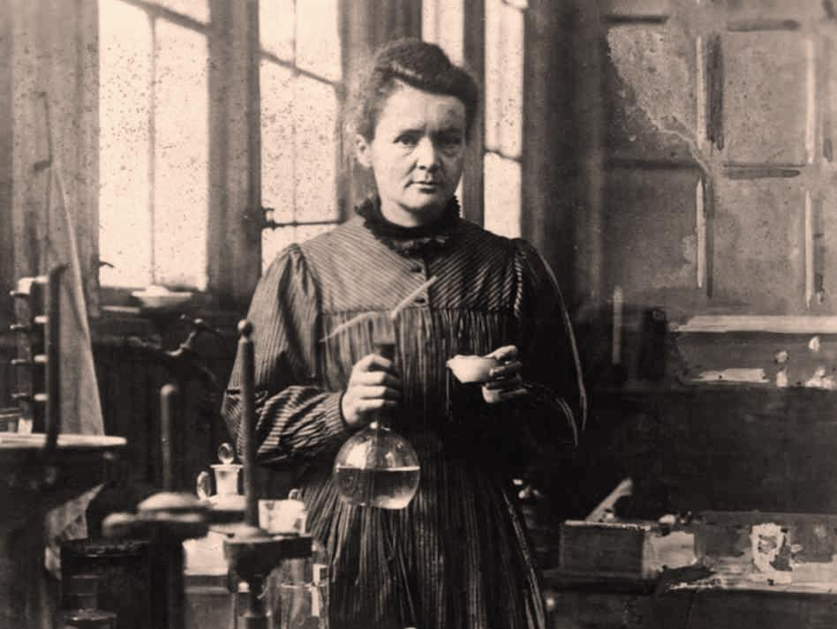
Name: Marie Curie
Years: 1867-1934
Quick Facts
- Discovered the elements Polonium and Radium
- Received Nobel Prize for Physics in 1903 and Nobel Prize in Chemistry in 1911
- Was a pioneering figure in the study of radiation
- She said “Nothing in life is to be feared, it is only to be understood. Now is the time to understand more so that we may fear less.”

Source:
- http://www.livescience.com/38907-marie-curie-facts-biography.html

